Venue:
University of Galway – Ollscoil na Gaillimhe
Room:
(THB-G011 Seminar Room)
Level 1
Áras Uí Argadáin
Hardiman Building,
Galway.

Getting there:
https://clients.mapsindoors.com/nuigalwayweb/9167eab0dc78437c93c76b57/details/91823fae26bd4a5ca720db4e

Parking:
Parking options on campus are limited to Pay and Display parking spots. Clamping is very active, so people are urged to be compliant.

Parking-Locations_Galway-A4-Map_26012023.pdf (universityofgalway.ie)

Travelling by Public Transport:
Galway is easily accessed by public transport.
- Trains:
Galway's train station is just off Eyre Square. The city is very well serviced by rail and only 2.5 hours away from Dublin. Find out more information on services and timetables.
- Buses:
You can travel to Galway using frequent services offered by our public bus service, or use one of the private bus services such as CityLink or GoBus. Direct (non-stop) buses from Dublin take 2.5 hours.
- Galway City public transport:
From the city centre, you can take a taxi to the University, or take the No.4 Bus in the direction of Newcastle from Eyre Square, near the train station, which is the normal drop-off point for buses.

Map:
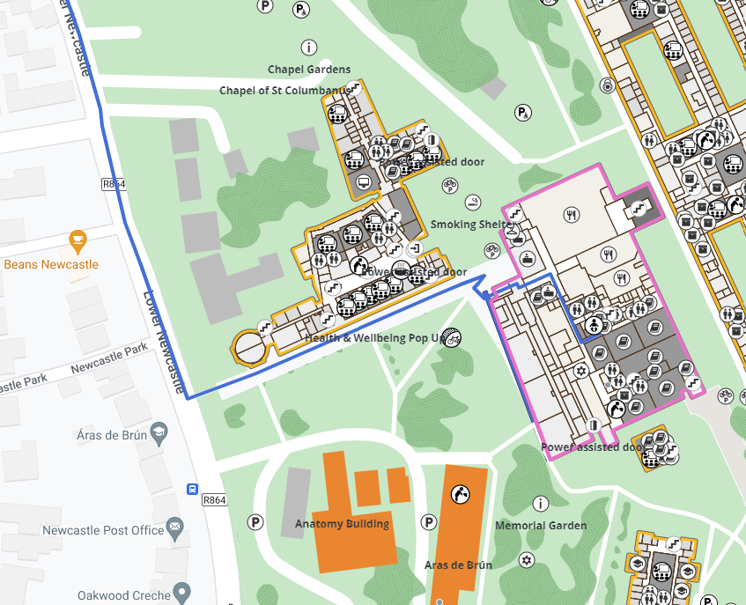

Additional resources:
How to find us - University of Galway
Maps - University of Galway

