Venue:
The Pavilion
University of Limerick
V94 F7XW
Ph: 061 213 369

Room: Pav 2

Parking:
There is complimentary car parking available at the Pavilion
(Beside the pitch, 2 min walk to the Pavilion)

Getting There:
https://www.google.com/maps/dir//The+Pavilion,+North+University+Court+University+of,+Limerick/@52.6792034,-8.6521565,12z/data=!4m8!4m7!1m0!1m5!1m1!1s0x485b5e908ecbdc5d:0x8fb42a862e13264b!2m2!1d-8.5697567!2d52.6791279

Travelling by Public Transport:
Limerick is easily accessed by public transport.
- Trains:
Colbert train station is just 5-minute walk from the city centre. The city is very well serviced by rail. Find out more information on services and timetables.
https://www.irishrail.ie/en-ie/station/limerick-colbert

- Buses:
There are several buses that service University of Limerick
Bus Stop Connections for University of Limerick
There are buses that depart from the city at Lower William Street
at regular intervals. #323, #304 #304A. Travel time is appx. 25 mins.
Map:

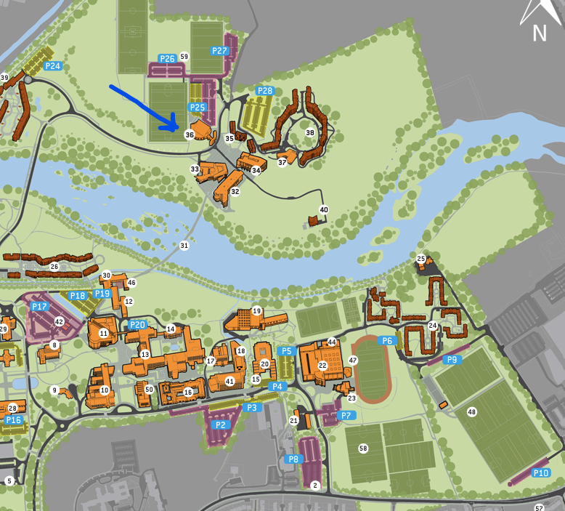

The Pavilion, #36 locator on the map

